**WGU's Four-Step Tool** (based on "[Six Steps to Thinking Systemically](https://thesystemsthinker.com/six-steps-to-thinking-systemically/)" by Michael Goodman and Richard Karash)

**STEP 1: Complete an Iceberg Tool for this case study.**

*The Iceberg Tool is a way to see how the structure (that is, the background of the case) ties together the individual events and the patterns and trends that emerge from recurring events. Using the Iceberg Tool allows you to see the basic facts and interconnections, an important first step.*

**Iceberg Tool to Understand Patterns and Structure**

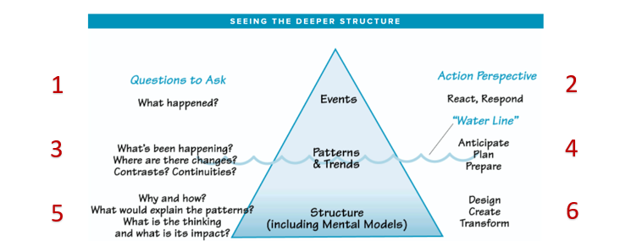

Iceberg tool shows events at the top, patterns and trends at the water line, structure near the bottom and less visible.

**Questions to Ask**

1. What are the key events in this case study?
2. What patterns do you notice in the key events of this case study?
3. What structure(s) explain the patterns of events in this case study?

**STEP 2: Draw “Behavior Over Time” Diagrams.** (Use as many blank BOT graphs as necessary, given the case study)

*The BOT diagram helps you identify how human behavior plays out over a specific time period; here, the time is the period in which the case study occurred. It is best to group similar events or patterns together in a diagram; for example, you might create one BOT diagram showing the actions of different team members (all actions) and another for the investments made in marketing campaigns and the resulting return on those investments (all money).*

**Time**

**Behavior**

**Time**

**Behavior**

Behavior Over Time diagram; the x-axis is labeled “time”; the y-axis is labeled "behavior".

**STEP 3: Select the systems archetype that best fits the case study.** You may wish to refer to Section 2, Lesson 2.1.

*The value of the eight systems archetypes is that they represent common problems within systems. If you can find an archetype that fits the system and the problem(s) you are confronting, you can use established ideas for dealing with the problem(s).*

*Examine each archetype carefully, comparing its causal loop diagram and text description with the given case study to see which one is the best fit.*

1. Which archetype did you select?
2. Why does this archetype best fit the given case study? Explain how its causal loop diagram and text description match up with the facts of the case study.
3. What is the main problem that needs to be addressed in this case study?

**STEP 4: Generate a solution to the problem.**

*Systems thinking is a mindset and a process focused on identifying and solving problems. Without problems, there is little need to think systemically. In this step, you consider a full range of possible solutions and select the best one.*

1. What solution do you propose for the problem in this case study?
2. What are the strengths of this solution?
3. What are the challenges of this solution?
4. What other alternatives did you consider **AND** why is your selected solution superior to each of them?
5. What do you project the impact of your proposed solution will be on the overall system described in this case study?